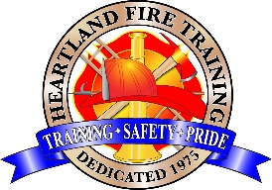

Heartland Fire Training Facility

Common Passenger Vehicle Rescue Technician
(CA State Certified)

COURSE DESCRIPTION:
This course provides the knowledge and skills to prepare an emergency responder to extricate victim(s) from a common passenger vehicle in a safe and effective manner in accordance with AHJ policies and procedures. Topics include sizing up an incident; creating an incident action plan; establishing safety zones; mitigating hazards; stabilizing and creating access and egress openings for rescue from a vehicle resting on its wheels, side, and roof or in a multi-hazard configuration or environment; disentangling and removing victims; and terminating an incident. This course incorporates awareness, operations, and technician training based on NFPA 1006 (2021).

PREREQUISITES: IS-100, IS-200, IS-700, IS-800 (FEMA – online) Public Safety-First Aid (CA Health and Safety Code 1979.182) CPR (CA Health and Safety Code 1979.182)

COURSE BOOK: None

DATES: October 5th, 6th, 7th, 2026

LOCATION: Heartland Fire Training Facility; 1301 N. Marshall Ave, El Cajon

TIME: 0900 – 1700hrs

PPE: Full structural personal protective equipment (including hand, eye and ear protection)

TO REGISTER: Complete online registration form. Payment due at time of registration.

Address: Heartland Fire Training 1301 N. Marshall Ave El Cajon, CA. 92020
Ph. 619-441-1693

HFTA FEES: $695.00 (Includes State Certificate/registration and other materials.)

