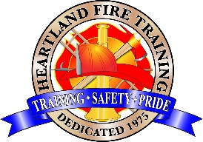

Heartland Fire Training Facility

Fire Control 3: Structural Fire Fighting
(CA State Certified)

COURSE DESCRIPTION:
This course provides the knowledge and skills that prepare a fire fighter to locate, control, and extinguish an interior structure fire.

PREREQUISITES: Meet the minimum job performance requirements for Fire Fighter 1 in NFPA 1001: Standard for Fire Fighter Professional Qualifications related to safety; fire behavior; portable extinguishers; personal protective equipment (PPE); ladders; fire hose, appliances, and streams; overhaul; water supply; ventilation; forcible entry; and building construction (NFPA 1403 (2018)) or SFT Fire Fighter 1 certification

COURSE BOOK: None

DATES: September 28th, 29th, 30th, October 1st, 2nd, 2026 (five day – 40hr class)

LOCATION: Heartland Fire Training Facility; 1301 N. Marshall Ave, El Cajon

TIME: 0830 – 1700hrs Classes start promptly at 0830 hours.

PPE: Fire/Rescue helmet; structural PPE pants/coat, SCBA.

TO REGISTER: To register, complete the online registration form. Payment is due at time of registration.
Address: Heartland Fire Training 1301 N. Marshall Ave El Cajon, CA. 92020
Ph. 619-441-1693

HFTA FEES: $800.00 (Includes State Certificate/registration and other materials.)

