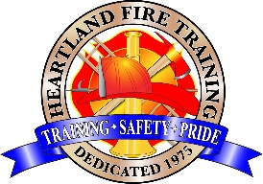

Heartland Fire Training Facility

Confined Space Rescue: Awareness
(CA State Certified)

COURSE DESCRIPTION:
This course provides the skills and knowledge needed for the awareness level confined space rescue technician to support an operations- or technician-level incident including sizing up an incident, identifying and isolating hazards, initiating a search in areas immediately adjacent to a confined space, communicating with victims, and performing nonentry rescue. This course does not qualify participants to make permit-required entries.

PREREQUISITES: IS-100, IS-200, IS-700, IS-800 (FEMA)*

COURSE BOOK: None

DATES: October 12th, 2026

LOCATION: Heartland Fire Training Facility; 1301 N. Marshall Ave, El Cajon

TIME: 0900 – 1700hrs

PPE: None required

TO REGISTER: Complete the online registration form. Payment is due at time of registration.

Address: Heartland Fire Training 1301 N. Marshall Ave El Cajon, CA. 92020
Ph. 619-441-1693

HFTA FEES: $300.00 (Includes State Certificate/registration and other materials.)

